THE PARADISE LAKE Gazette.. All the news that is fit to print
Third Edition August 2007
Lake Level Lowest in 50 Years

For many years we have seen Paradise waters’ cycle up and down. For the past 7 years we have witnessed our lake level go down without the usual come back. 2007 finds Paradise at an uncomfortable low, and having some neighbors asking what’s going on? The Gazette took on the task to investigate- What’s the low down on the lake?

We are currently in the 3rd worst drought in Wisconsin history. The 2nd worst drought occurred in 1988-89, from which this region has never fully recovered. Prior to the 1980’s, there was another major drought that occurred in the 1960’s.

In doing some historical research, we were able to get data back to the 1940’s, when the lake level was exceptionally high compared to current day. The owner of Camp Towering Pines said that our lake was at a level that nearly reached Nokomis. Others have commented on areas of the lake that are now dry land, were then, navigable by boat.
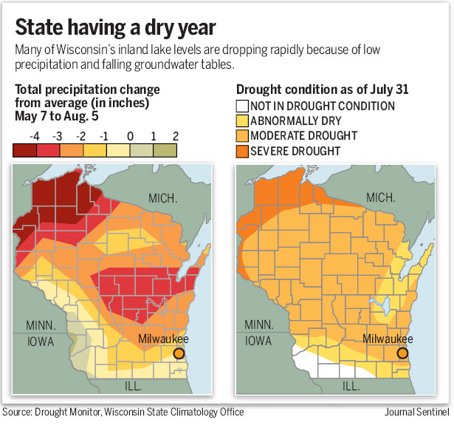
Lake residents have provided us with some recollections. Walt and Evelyn Helein reported that in 1964-65 the lake level was low enough for a truck to drive around the edge of the lake on the sandy shore. This report coincides with the drought that occurred the in the mid 1960’s. Kris and Larry Rowe report that the water level was back up with no beach in 1991; this was documented in a dated photograph. Fred and Sonja Roediger remember that the lake was 10-12 feet closer to their home in 2000 when they moved in. They had to get extra sections of dock to avoid stepping in the water on the way out to their pier. Other residents seem to verify that there has been a slow decline of lake levels without a rebound after 2000, which coincides with the present drought. So what is the rainfall? Annual precipitation in northern Wisconsin dropped from 36 inches in 2001 to 31 inches in 2005 and 22 inches last year 2006. As we know 2007 has not been a bumper year for snow or rain.

To report more accurately about Paradise Lake, a number of
experts were contacted. Paradise Lake is a seepage lake with
no inlet or outlet and is dependent on precipitation and
groundwater for its water supply.
Water levels in seepage lakes fluctuate in Wisconsin
between 2½ and 11 feet, where water levels in other lake
types only fluctuated between 1½ and 4 feet.
The range of fluctuation in seepage lakes is often greater
because they have less water to draw from - they’re main
source of water may be a limited groundwater supply.
Other lakes may have a larger water source to draw from,
including inflow from streams.

Located in the “Northern Highlands” Region of Wisconsin, the elevations are higher in this region than elsewhere in the state and this area is most affected by drought conditions. Locally Paradise is the highest of the surrounding waters being 5’ higher than N. Nokomis lake and 7’ higher than Dam lake. This elevation has a pronounced effect on groundwater levels. Interestingly, the lake is like a window into the aquifer (groundwater) beneath it. In order for lakes to refill, the surrounding aquifer must be refilled.

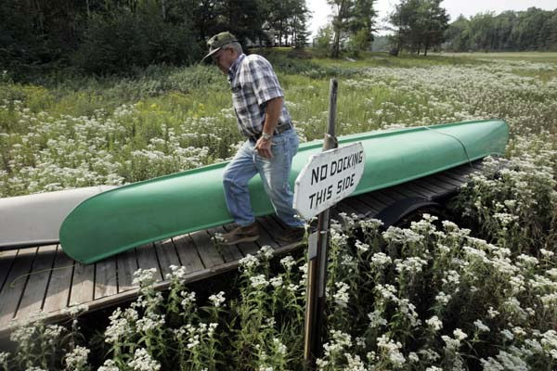
Aquifers are recharged during the fall and spring when plants and trees are dormant. Late Spring/Summer water is used by the plants and trees so summer precipitation is not a factor to refill the aquifers. Were it possible to pump water back into an 80- acre lake like Paradise, 2.2 million gallons would need to be pumped into the lake to increase the water level by one inch. Additionally unless the aquifer surrounding the lake was full, the water pumped in would just drain back out to the aquifer since Paradise has a sandy bottom. To raise the water level in a lake, the level of all the groundwater surrounding the lake has to be raised; snowfall run off along with fall and spring rains are vital to restoring groundwater levels.

Experts made it clear that Paradise is not alone. Ground water
lakes like ours are down all over. A consensus was however,
that we would need 10 winters in a row with heavy
snowfall to restore the levels to what they were years ago.
Long Lake

There is another issue besides “mother nature”; that being the lake is being drained “for agriculture.”
In the Wisconsin State Journal July 1, 2007 an article titled “What was a Lake is now a Mud Hole”
discusses what happened to Long Lake, a one-time 40-acre lake with trophy bass. “Long Lake was lost due to drought and high-capacity wells, mostly used for farm irrigation.
Paradise does have one deep well for irrigation within 1000 feet of its shore however the experts we contacted did not consider this an issue. “ Within 1 mile of Long lake is 13 high-capacity farm irrigation wells, pumping up to 720,000 gallons of water a day”.
Although they have not conducted an official geological study of Paradise, experts think that groundwater which is pumped to water local fields does affect us, but not appreciably at this point. They felt that our present low lake levels were attributable to the drought. In addition, 1-2 per inches can evaporate off of a lake during a hot summer day. Two of the experts were hydro-geologists who looked at topographical maps of our area said that the low lake levels in our lake was mostly likely natural and not related to agriculture. Sand and Dam lakes get the run off
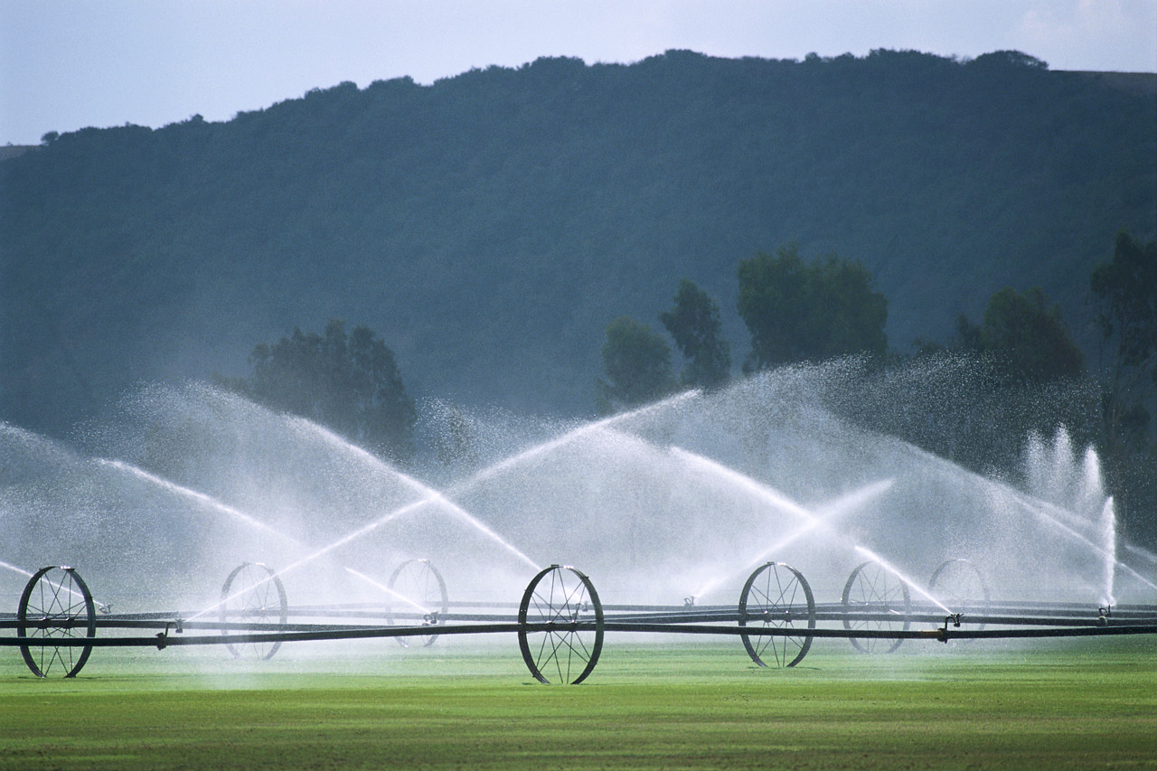
from the farmer’s field, which is on County “D”.
It is not likely that Paradise is as directly affected by
Agricultural fertilizer.

Should the residents on Paradise Lake want to study
the lake, it would be possible to do a geological or lake
improvement study to confirm if any factors such as
agriculture were affecting our lake levels or quality. Cost
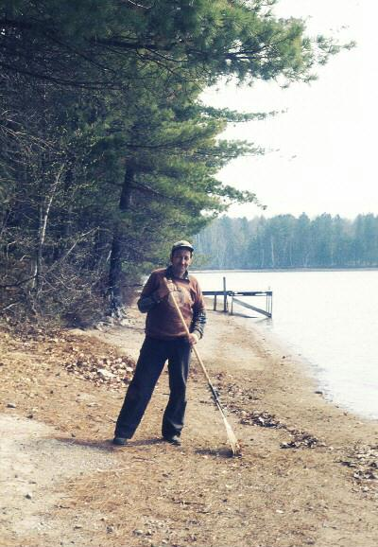
of a geological study is estimated at several thousand dollars. State grant funds are available for various studies or lake improvements, however in order to qualify for such a grant, Paradise Lake would need public access.

The lake and water specialists contacted, suggested that
it would be helpful to try and avoid pulling water directly
out of the lake for irrigation purposes and also helpful if residents
watered lawns in moderation during the drought. They also
suggested that lake residents not use any fertilizers with phosphorus
in them.
Paradise Beach 1964

There is some hope the “La Nina” weather conditions that we seem to be entering into might create conditions that would increase the type of seasonal precipitation that is needed to recharge the aquifers in the Northern Highlands, however, there is much speculation about how global climate change might be affecting our region. We may be in a global cycle or another regional cycle, but it is quite clear that our lake has gone through numerous up and down cycles, some of which that have been fairly extreme over the past 40 years. We may never see the lake return to the high levels that some of our residents remember back in the 1940’s and 50’s, but it seems that what the lake is currently experiencing is a natural process.

Periods of lake water recession are actually good for the health of a lake. One reason is that reduction of lake levels allows for the growth of vegetation around the edges of the lake that is good for wildlife.

Sources:
Jim Grafelman Oneida DNR/ Water Zoning Department
Chuck Fitzgerald and Kevin Gauthier/ Oneida DNR Water Specialists
Ken Bradbury, hydro-geologist from the Geologic and National History Survey Department
George Kraft, hydro-geologist from The Central Wisconsin Groundwater Center
Tim Asplundh/ Madison DNR (studies regional groundwater trends and lake levels)
Special thanks to Gazette reporters Julie LeDoux and Nicole Nickulas



Fire on Paradise
Having a campfire on Paradise is a great way to spend the evening. However some neighbors are seeing a few fires that have gone unattended. Under normal circumstances no permits are required for warming or cooking fires (campfires) in Wisconsin. However, when very high or extreme fire conditions are reached, the state can enact temporary fire restrictions that will either limit or prohibit the use of campfires. Under any circumstances, YOU are responsible for maintaining a safe campfire and can be held liable for the suppression cost should you cause a wildfire.
If a fire is desired and conditions are favorable, use an existing fire ring. If there is not one available, ensure with the property owner that construction of campfires is allowed, and then follow the guidelines below for setting up and extinguishing your campfire.
Be careful where you build your campfire: Select an open level spot away from trees, overhanging branches and dense dry grass.
Be sure your fire can't spread: clear a ten-foot fire circle to bare soil around where your campfire is going to be. (scrape with your shovel)
Dig a shallow hole in the center of your fire circle then circle the pit with rocks to shelter the campfire from the wind and help keep burning materials inside the pit.
Never leave your campfire unattended and always have a shovel and bucket of water on site.

Note…At Gazette Press time there is a ban on all fires due to dry conditions

Towering Pines
Summer camp for boys

Camp Towering Pines
80 boys enjoyed Towering Pines this summer. Did you know the camp uses Paradise Lake for scuba?
Please keep a sharp eye for Scuba flags if you are motor boating. Additionally, keeping the camp full of boys, will keep the camp. Talk up Towing Pines

Paradise Lake Family Adopts… Highway O
By Julie LeDoux
Our family loves to walk and bike the beautiful roads surrounding Paradise Lake. We enjoy the lovely scenery, fresh air and exercise, but we are often troubled by the amount of trash that we see along the roads. One might not notice this while driving through the area, but there is an alarming amount of trash that accumulates on the roadsides.
Since we already do a lot of walking, it just seemed natural to take along a trash bag and start picking the trash up. As we walked and biked, we also noticed the "Adopt-A-Highway" signs along the way and decided to find out about the program.
Turns out anyone can Adopt-A-Highway. They request that you take on a two-mile stretch of road and do a trash pick-up twice a year. Our family is only here in the summer time, so we could only commit to doing it once a year. The highway department was happy to have whatever help we could offer, so we became the proud adoptive family of a section of County "O". The Highway Department provides adoptive families and businesses with safety vests, a supply of trash bags and they put up a signs on the section of the road you have adopted to note your community service. Give them a call and they will also come to collect the trash that has been gathered. It just takes us part of an afternoon for us to do our part, and it is a joy to see the clean roadsides we when have finished our trash collection.
Right now, much of County Road "D" is orphaned and it shows. There is quite a lot of trash that has accumulated along this road, and, it is really sad. What a great gift to the Northwood’s it would be if a more folks took their exercise walks with trash bags in hand along County "D" and any other roads nearby that may need attention.
If you are interested in taking care of a needy roadside, contact Jeri Cooper at the Oneida County Highway Department (715) 360-6184, jcoooper@co.oneida.wi.us She will give you all the information you need and help get you started.
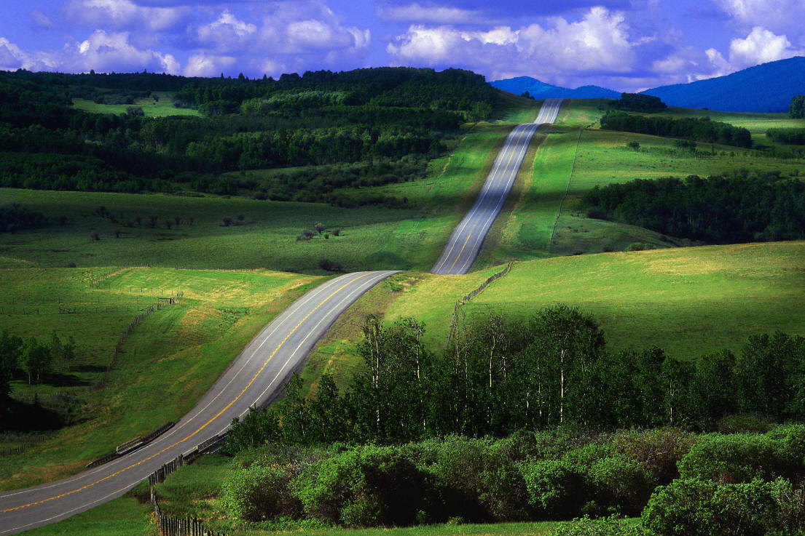

Fishing on Paradise
The majority of neighbors seem very happy with the current “non stocking” climate in our lake.
More Perch and blue gills are coming alive, which is a natural fish in these clear waters as opposed to the walleye stocking.
If your opinion is for stocking fish, the Gazette would like to hear from you.

The yellow perch (Perca flavescens) is a species of perch found in the United States and Canada, where it is often referred to by the shortform perch. Yellow perch have 6-8 dark vertical bars on their sides. The yellow perch is in the same family as the walleye and sauger, but in a different family from the white perch.
Yellow perch size can vary greatly between bodies of water, but adults are usually between 4-10 inches (10-25.5 cm) in length and weigh about 5.29 oz (150 g) on average. The perch can live for up to 11 years, and older perch are often much larger than average; the maximum recorded length is 19.6 inches (50 cm) and the largest recorded weight is 4.2 lb (1.91 kg). Large yellow perch are often called "jumbo perch."
The perch spawns at the end of April or beginning of May, depositing it upon weeds, or the branches of trees or shrubs that have become immersed in the water; it does not come into condition again until July.
Yellow Perch are one of the finest flavored of all panfish. The best time for fishing for perch is September to February, though they bite reasonably well all year and are readily taken through the ice. They haunt the neighborhood of heavy deep eddies, camp sheathings, beds of weeds, with sharp streams near trees or bushes growing in or overhanging the water.
The best baits for perch are minnows, earthworms, shrimp and artificial lures. The tackle should be light. If fishing off the shore, one can use the simple but effective bobber and bait technique. If fishing from a boat, tie on a snap swivel to your line then adding a small 2 Oz. swivel weight to it along with a #5 snelled hook. Bait the hook with a whole earthworm and drop the line directly below the boat. Let the bait sink all the way down to the bottom, and when reaching the bottom, reel in a couple hundred notches to keep it suspended above the bottom higher than a couple feet. Keep the line curvy and tense or you won't feel the Perch's bite. Perch have an uncanny way of biting on the bait without the angler knowing it.

Yellow perch, Perca flavescens
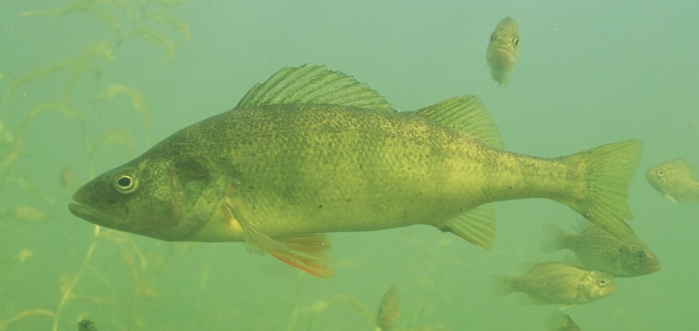

The Bluegill (Lepomis macrochirus) is a species of freshwater fish sometimes referred to as bream, brim, or coppernose. It is a member of the sunfish family (family Centrarchidae) of order Perciformes. It is native to a wide area of North America, from Québec to northern Mexico, and has been widely transplanted to stock game fish for anglers. It is commonly fished in Minnesotaand Wisconsin but it is the state fish of the U.S. state of Illinois. It is renowned as an excellent tasting fish on par with Walleye. . They prefer very warm, quiet, shallow waters under the cover of weed beds and submerged brush. Just before winter seals the lake with ice, look for bluegill in 4-6 foot waters. After "ice-on," and again a few weeks before "ice-off," bluegill fishing is at its best! Bluegills are usually caught in 12 feet, of water or less during this time. When winter temperatures are bitter, they drop to warmer waters up to 20 feet deep and are not as easy to catch.
Garden worms are the favorite bait for bluegills, but they can be caught on a number of different types of lures. Wintertime jigging in the weed beds with grubs or a bright-colored, teardrop lure produces excellent results! You can also get good results with earthworms, rat-tail, mealworms, wax worms, and goldenrod gall larvae. Jig the line 4 inches up with a flick to get the lure flashing under water. Be sure to use light tackle for these easy biters and try fishing in shallow bays where the water is about 4 to 8 feet deep. A small bobber may be your only clue to the slight feeding twitch of the bluegill.
State Record Catch Size: 2 pounds, 9.8 ounces, 12 inches long, Green Bay, Brown County, WI.

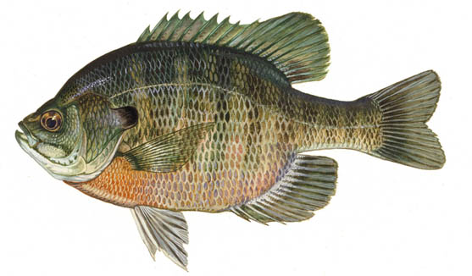

My First and Most Dramatic Public Speaking
By Carolyn Hauswald Bosher
This is a series of articles on the history of residents on Paradise Lake
Seven days after I was born, Japan bombed Pear Harbor so during my infancy war was a part of daily life. I can’t say that I remember anything about it but I do remember the end. My Father was a teacher so we had the whole summer to come to northern Wisconsin and live a very isolated life on what was then “Clear Lake” now called Paradise. It took two days to get here and most of the last day was on gravel roads. In the early years our cabin, the Ciras and the Gotleabs, who never seemed to be here, were the only sign human life on the lake other than an occasional sighting of the boys from the camp in their canoes. Legally we only owned 100 ft of lakefront but the whole lake was our playground. Those were the days of the outhouse, a hand pump, and a barrel on the roof water system, kerosene lanterns, certainly not electricity and computers. Our only connection with the outside world was the car radio.

My earliest memory of a specific incident at the cottage took place on August 10, 1945. I was 3 ½ and my sister, Jeananne, had just had her first birthday. Mom, Jeananne, and I were down on the dock playing in the water and Dad had gone up to listen to the noon news on the car radio. It was already a very interesting day at the lake because all the Cira brothers were at the lake that day too.

They were swimming and diving off of their spectacular dock. Our dock was flat, boring, and close to the water. Theirs was made of poles, probably maple, about 3” in diameter driven into the lake bottom in pairs about every 8’ and sticking up every which way about 8’. They were then sandwiched between two boards nailed about 4’ above the water, which served to keep them parallel, and loosely support long planks that were laid on top. It was just exactly like the picture that would later appear in my Huckleberry Fin book. The planks weren’t nailed down because they bounced around and occasionally flipped off altogether, which made for hours of interesting entertainment.

Suddenly the car horn started honking and honking. It was startling and exciting all at the same time. What could possibly be the matter? Mom told me to run up the stairs and find out why Dad was honking the horn so up I went on this urgent mission. I came running around the corner of the cottage and saw my Dad sitting in the 1936 Ford, sort of sidesaddle, one foot in and one foot on the ground; and most alarming he had tears in his eyes. I stopped short. I had never seen my Dad cry.

He said, “ Run quick. Go tell you Mom the war is over!”

I turned and ran around the cottage and ran down the 10 steps waving my arms and yelling “THE WAR IS OVER! THE WAR IS OVER! THE WAR IS OVER! THE WAR IS OVER! THE WAR IS OVER! THE WAR IS OVER! THE WAR IS OVER!
THE WAR IS OVER!

I have no idea how my Mom reacted because what happened at the Cira’s was the most spectacular event of my three and one half years AND I was causing it. All of these draft and slightly pre-draft age boys were yelling and screaming, leaping in the air, diving in the water. Skinny adolescent arms and legs and planks were flying everywhere. I have spoken to many audiences since but I have never been able to capture attention or call to action so effectively as I did that day with my four-word announcement. I am told that I went around repeating it for days and days seeking a repeat performance up and down the lake. And that is how the news of the wars end came to Paradise.

Their Back in Wisconsin…The American Eagle, 1150 pairs to be exact.. With 118 calling Oneida County Home
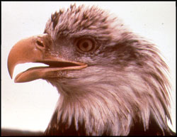

Wingspan: 7 feet (Wow, that's long)
Weight: 8-14 pounds
Length: Female 34-43 inches, Male 30-35 inches
We all know the bald eagle as a national symbol with its distinctive "bald" white head, tail, and dark brown body. These are adult bald eagles. They get their distinctive "bald" head and white tail when they are 4 or 5-years-old. The younger birds are dark brown with just a touch of white on the under wings and tail, making it hard to tell them apart from large hawks or golden eagles. Have you ever seen one up-close?

You'll see that their powerful beak, legs, and eyes are yellow. Females usually lay two, 3 inch-long white eggs in late March or early April. Both adults incubate the eggs. Within a month or so, the first egg will hatch with a fluffy white chick. Adults then feed the chicks bits of fish and protect them from severe weather and predators, like great horned owls, raccoons, and ravens. Active nests have been found both in inland nesting areas and along the major rivers in Wisconsin: the Chippewa, Lower Wisconsin, Wolf, and Mississippi. Eagles usually build their nests in tall trees, often a live white pine, with large sticks as shell and softer material as the lining. On average, the nests are about 4 feet in diameter and 3 feet deep, compare that to your height and you'll see how large they really are! Sometimes an eagle pair may just
"refurbish" an old nest with new materials instead of building a new one. Just like fixing up an old house instead of building a new one.

Each year since the passage of the Endangered Species Act and the ban of DDT bald eagle populations have been on the rise. DDT is a powerful insecticide, which accidentally affected eagles and other birds by causing their eggs to have thin shells that broke. This kept the birds from hatching. In 1973 there were only 108 occupied eagle territories in Wisconsin. In 2007, there were 1,150 breeding pairs
How do we know how many eagles and eagle nests there are? Well, the DNR and many partners, like the U.S. Fish and Wildlife Service and the National Park Service, have been working hard to collect data about the eagles for the last 25 years. These groups conduct breeding surveys to find out how many nests are active by flying over eagle territory to find nests, then they go back and count the young in each nest. This information is mapped using a computer program called "GIS," Geographical Information System. From this system, we can link all of the data to identify where breeding habitat can be found and predict where more eagles may nest. On the ground, volunteers also climb the nest trees and band eaglets with a metal leg band, take blood samples to check for disease or contamination, and collect vital information on eagles that have been injured or died. You can help the bald eagle in Wisconsin by Adopting an Eagle Nest, reporting active eagle nest sites to the Bureau of Endangered Resources at the DNR and learning more about eagles.

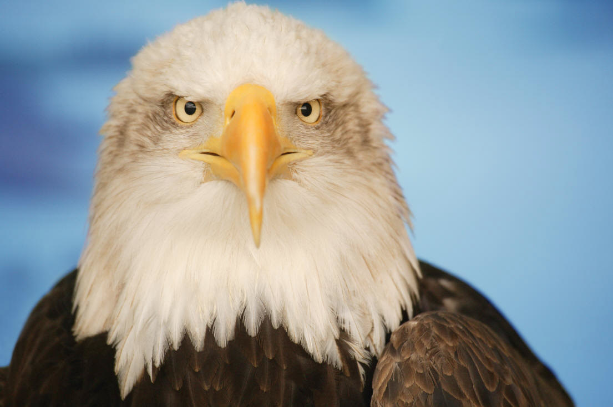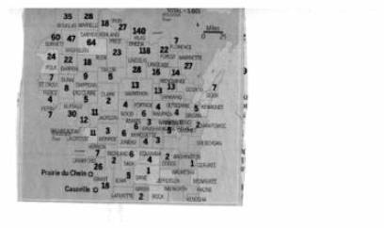

Bon Appetite! 
By Karen Lamb and Nancy Cameron
The Gazette has two roving reporters who have taken on the mission to try the local eating establishments. They are focusing only on the positive; so here is their recommendation

Breakfast
Wolf Pack Café St Germain
Ellas Woodruff Hwy 70
Farmers Wife Eagle River Hwy 45 toward Three Lakes
Sunday Brunch Eagle Waters- Range line Road Eagle River

Pizza
Knockers County trunk H Sit outside on deck or eat in
Vinchies
Spangs Good tomato bread and pizza

Lunches are great at
Brew Moon Eagle River they also have wireless Internet
Flour Sack Eagle River, Thanksgiving dinner sandwich
Farmers Wife
Baertschys Eagle River
Thirsty Whale Minocqua Great lunch and fish fry
Polecat and Lace Minocqua

Dinners
Fibbers Try Wednesday Mexican Night and 2 for1 Margaritas
Scoobies North Sayner Friday or Tuesday all you can eat fish and chicken
Four Seasons Fish Fry
Honey Bear Fish Fry
Norwood Pines Minocqua past Wal-Mart, Fine dining in an old log building
MaMas down the hwy from Norwood Pines
Robs Loose Moose Land O Lakes
Bents Camp Land O Lakes Gorgeous old log building great view and super view, worth the drive
Little Bohemia Hwy 51 North John Dillinger hangout, historic old restaurant
Neros Eagle River Good Italian food and salads
Crossroads hwy 17 toward Rhinelander Sports bar New log building serving soups and sandwiches Sweet potato pies

Rentals On Paradise
Paradise Lake is zoned for single family. Most neighbors probably don’t mind if you occasionally rent out your cottage to a friend or relative. However its been reported to the Gazette that a few neighbors are renting on a regular basis. The zoning restrictions are made for a reason, and will be enforced. If you are renting you home on a regular basis, please stop. The fines are considerable and the mood on the lake to report violators is active and ready.

Welcome
We have a Welcome service Hostess in the area. Anyone who has moved to our lake and plans to live here no less than 6 months, and has moved here within the last year please contact Jan Kazda 542-3685 for a wonderful gift bag of certificates from local businesses.

Welcome

Some new neighbors on Paradise!
There is a new A frame on the Lake (8291 Silver Shores) and its proud owners are the Pryde’s
Pat, Nancy, Kaitlin (13), Sam (10), Emily (7), Honey (the cat) and baby Luke who will be here soon! From from Dunlap Illinois (central Illinois). The Pryde’s spend time fishing, riding the bike trails, and enjoying the beautiful Northwood’s!

Letters to Editor From One Boater to Another...
Dear neighbors, As boaters, we love to ski and tube and buzz around the lake. I think most of us really try to be mindful of safety and common sense and we really try to be aware of the needs of others on the lake. Still, I am sure we are all far from perfect. Sometimes we are having so much fun that we get distracted or are too noisy. Sometimes it takes forever to get a skier up or someone keeps falling. Our wakes can bother folks, the sound can bother folks, and sometimes we just annoy people. But honestly, I don't think we mean to.
As boaters’ skiers, jetskiiers, I think most of realize that we have a lot of responsibility to be extra cautious and to be good neighbors since our boating affects others differently than slower boats do. So, from one boater to another lets remind each other to be safe and to be thoughtful of others. Let's remind our guests as well.
Here are some things our neighbors appreciate: Quiet Mornings, and quiet evenings, staying as far away from docks as possible" taking turns with our boats when there are more than a couple boats out.... "
And, to our neighbors who do not use speed boats or jet skis, thank you for your patience with us when from time to time when we get on your nerves. If there are reasonable things we could do to make things better around the lake, tell us politely and with a positive attitude and we can work together to learn to share the lake better.
Signed,
Love this Lake (Three neighbors penned this letter) and the editor accepts their signature

3 cheers for the Gazette… from camp counselor Towering Pines

Editor note. Please send Gazette article ideas to Margie Keehn Margaret.keehn@med.ge.com or Marge Berg 715-479-7499

CLASSIFIEDS 

Our Neighbors the Schei’s have a booth at the St Germain Flea Market in the main structure. They sell wonderful things. Please look for them.

Love seat, Early American 40$ Very good condition 479-9868. If no answer, please call again.

Lakeland Aerial Photo has captured Paradise Lake from the air.-contact Kyle Tostenson at 715-360-0831.

Earthwerks & Antiques HY 70 St Germain near Cathy’s IceCream. Rustic furniture, Birch Frames, This and That
